# CS 255 System Design Document Template

Abigail Mattingly

## UML Diagrams

### UML Use Case Diagram

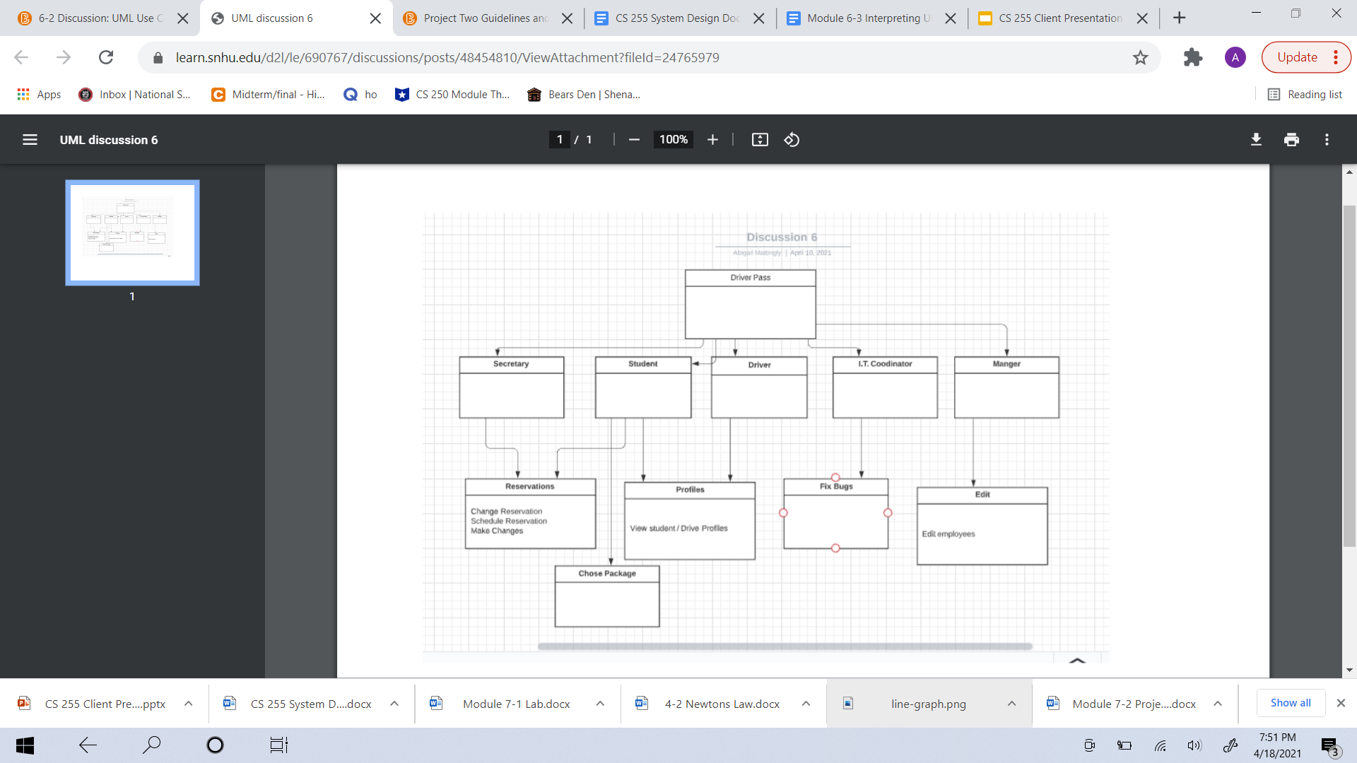

### UML Activity Diagrams

* + 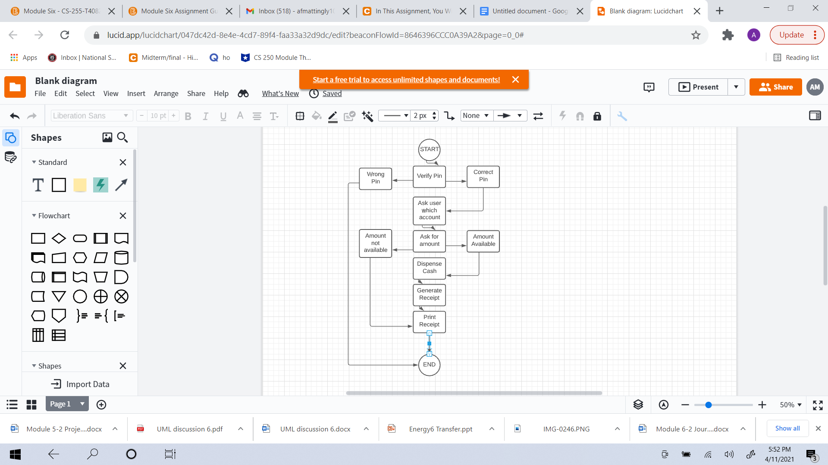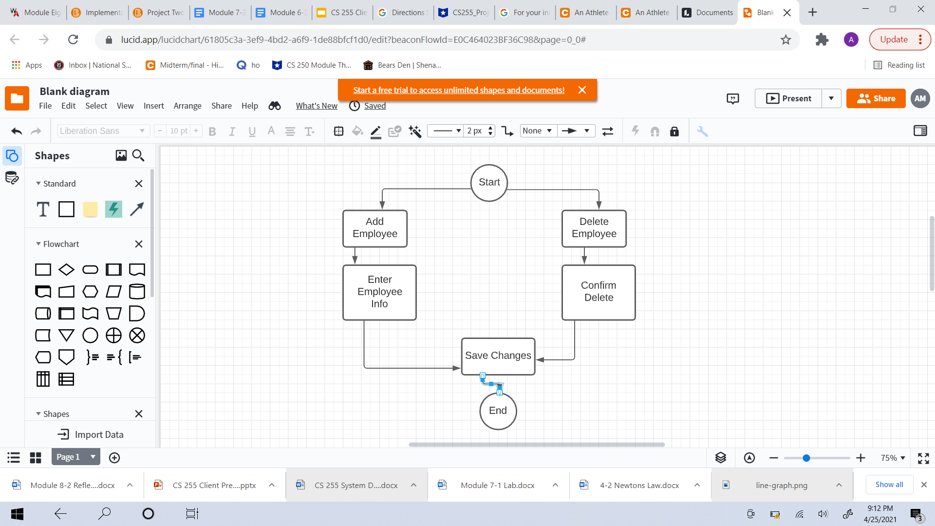

### UML Sequence Diagram

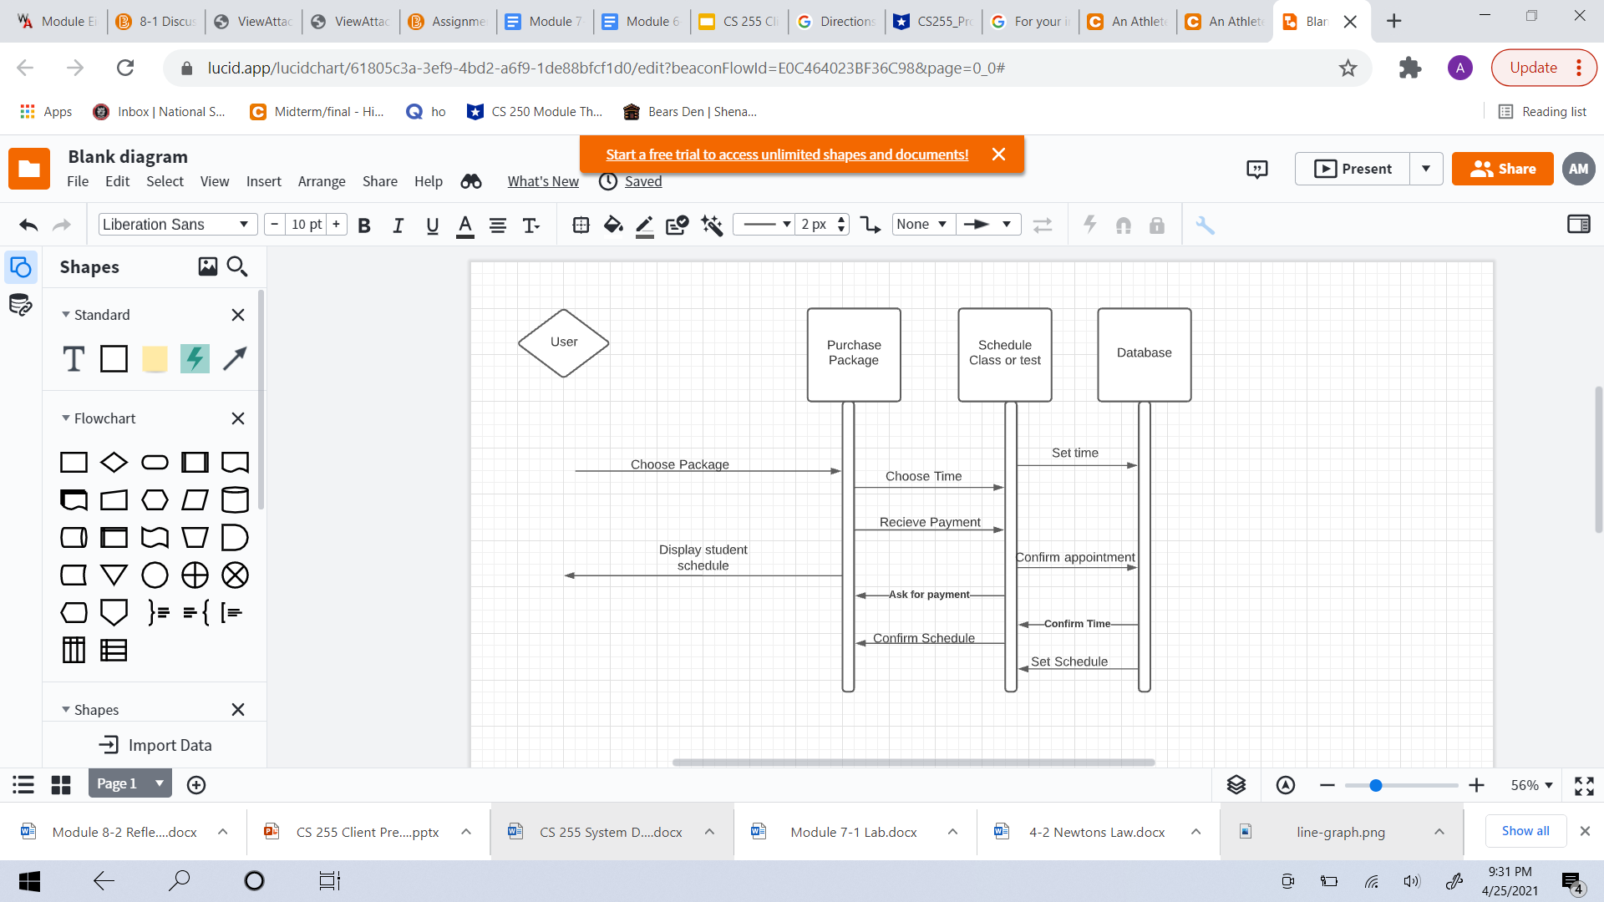

### UML Class Diagram

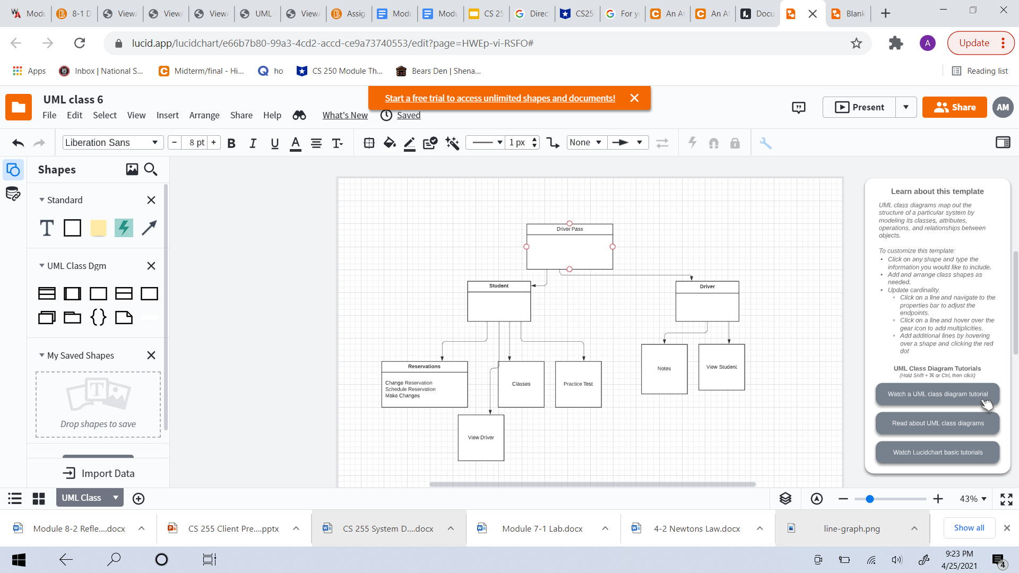

## Technical Requirements

* A device that can set up to the internet
* Reliable internet with a functioning speed
* Knowledge on how to work computes
* Neat and organized website
* Functional website
* Ability to run updates and bug fixes as needed